|  |
| --- |
|  |

|  |
| --- |
|  |

PY OS Improved

Manual help document

“Help you to use PY OS Improved from beginner”

Pages list

1. Install(Manually)
2. Basic usage

Install(Manually)

1. Open your terminal or cmd
2. Type “git clone <https://github.com/minqwq/pyos-improved.git>”
3. After previous step finished, type “pip install –r requirements.txt”
4. After all modules installed, Open folder “config”, and edit config.json, find this line: “isWindows”: “”, and edit “” to true or false by your system type.
5. Back to terminal or cmd, type “python pyosimproved.py”

Congrats, now PY OS Improved is successfully installed to your computer!

Basic usage

I know, you maybe dont know how to use terminal, but its easy, lets start learning.

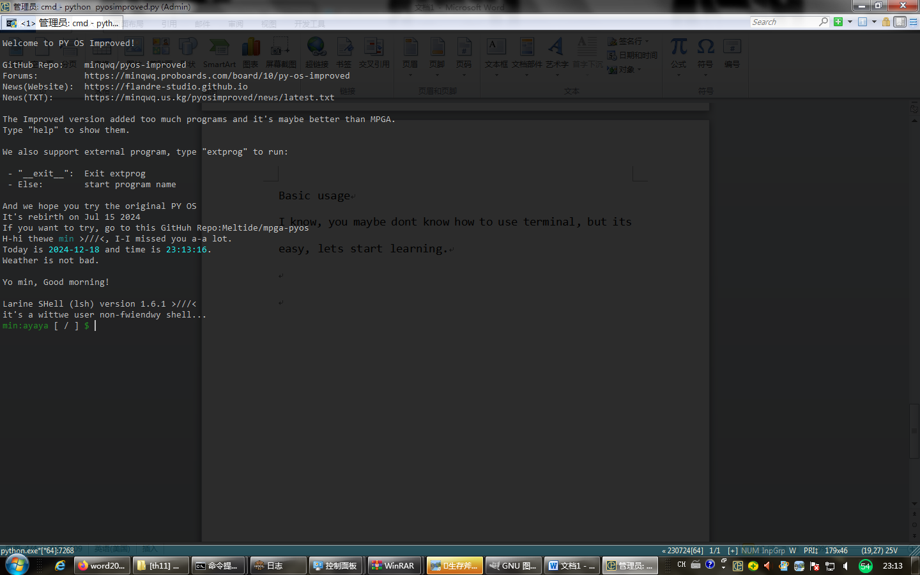

When you first enter PY OS Improved, you will see this interface, you may want to call me “WHY NOT USE GUI????”

ah, Because i like terminal and i cant make gui sooooo

Now, you want to know how to use it, right?

Type “help” and press enter to show all available command in PY OS Improved

And we also have extprog, the Extra application launcher of PY OS Improved

Usage is showed to you before.